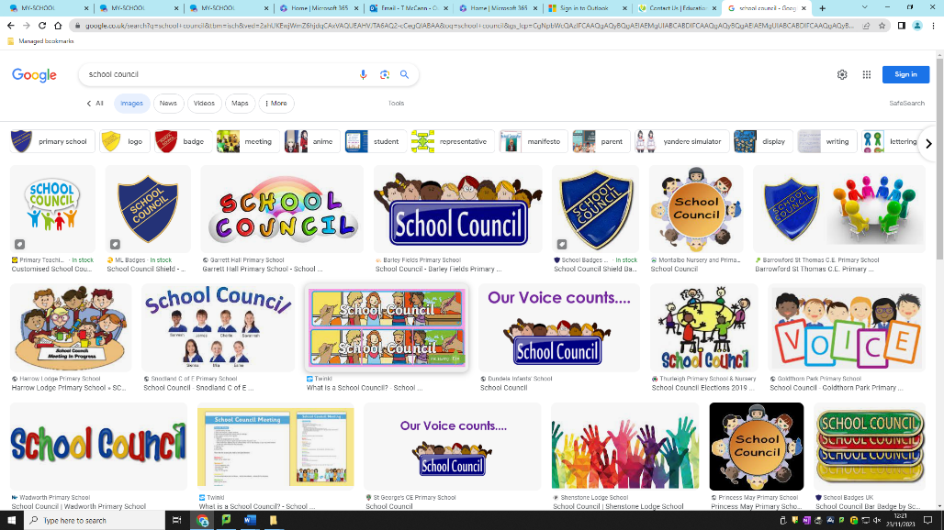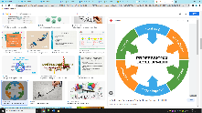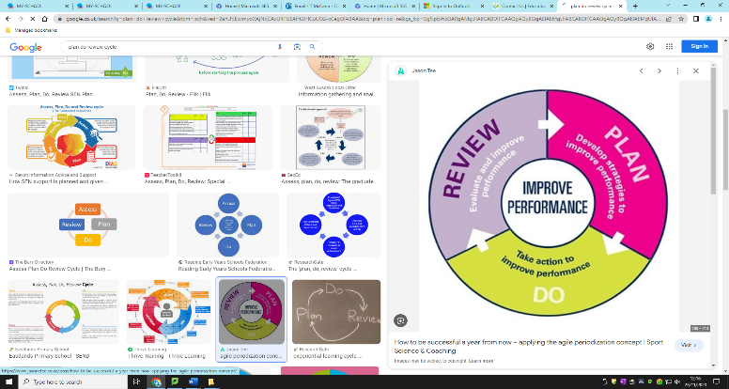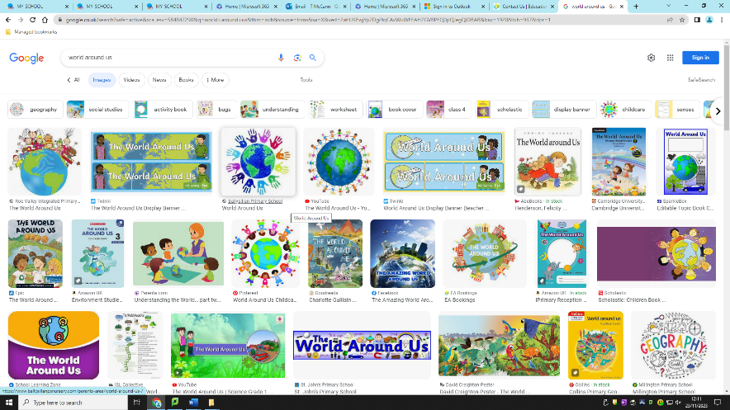

Community

* We will work with the parish to prepare for the sacraments and in our learning about God.
* Teachers and parents will meet to discuss how they can help us.
* We will continue to promote Gaelic games and work closely with the club.
* We will host a Foundation Stage Curriculum Evening for parents.
* We will make links with pre-schools and develop our Primary 1 Induction Programme.
* Each class will perform an assembly for our parents.

Our vision is to create a learning environment which gives every pupil the opportunity to develop their full potential and so be prepared for the challenges and opportunities of their lives ahead.

Development Plan Overview

2023/24

‘

Takes the hand, Touches the heart, Stretches the mind’

World Around US

* We will use our new polytunnel to help us learn about growth.
* We will use our skills in ICT, Numeracy and Literacy in our topic work.
* We will continue to look for opportunities to promote science.

Staff Development

* Assistants will be trained on how they can help us if we find reading difficult.
* Teachers will work on developing strategies to help us connect our learning across the curriculum.

Religion

* We will take part in Eucharist
* Adoration
* We will perform for our parents at Assembly
* We will learn about God and the importance of respecting ourselves and others
* We will take part in Masses throughout the year
* We will raise money for Trocaire, Saint Vincent de Paul and Mary’s Meals.

PDMU/ Health and Well-Being

* We will have lessons where we can learn to look after ourselves better
* We will take part in the Daily Mile
* We will take part in the Super Heroes Programme
* We will extend the number of After – School Clubs.
* We will develop out-door spaces so that we can enjoy play and learning outside.
* We will buy a polytunnel so that we can learn about growing plants and where food comes from.

ICT

* We will use our ICT skills to showcase our learning in other areas of the curriculum
* We will continue to make good use of the iPads and will have more opportunities to use laptop and desktop computers

Numeracy

* We will look for opportunities to use our mathematical skills across the curriculum.
* We will develop the language of maths throughout the school.
* We will continue to develop real life problem solving. We will use Dynamo Maths to help us if we are finding Maths difficult.

School Council

* We will vote for children to represent us on the school Council
* The School Council will share their work with Mr McCann and tell him what they enjoy doing in the classroom.
* The Council will help to decide how we do things in school
* The School Council will work hard to promote ways in which children are happy, safe and cared for.
* We will introduce a Junior School Council for P1 – P3

Assessment

* Teachers will use our tests to help us learn things we don’t know.
* Teacher will use our tests to help us celebrate our learning
* Teachers will record our scores and to see how well we are progressing.

Literacy

* We will look for opportunities to use our literacy in other subjects.
* We will become better writers.
* We will take time to learn the key features of the different genres and forms of writing.
* We will explore different texts, problem solve and use our findings to produce quality written work.
* The school will create new resources to support the teaching of writing.
* We will use NESSY and the Rapid Reading Programme if we need help with Literacy.